**Content**

|  |  |
| --- | --- |
| **Title** | **Pages** |
| Introduction   * Document purpose * Product Scope | 03  03  03 |
| Overall description   * Product Perspective * Functional Requirements | 04 - 05  04 05 |
| User Interfaces | 06 – 12 |
| Conclusion | 12 |

**Introduction**

The Medcure Pharmacy Management System is a tool for purchasing medical related stuff online, specially designed considering the current pandemic situation that makes the customer buy medicine easily and safely. The system operator will get full access to customer information through the proper management tools.

**Document purpose**

The main objective of this Software Requirement Specification for a Pharmacy Management System is to establish the basis for the project. Moreover, it gives an intensive explanation of how the system is to be implemented and what users can expect from it. Detailed functional and non-functional requirements are generated in this document based on the client’s expectations and requirements, so that the development team can follow them with a clear understanding to build a system tailored to meet end-user needs. In addition, it serves as a blueprint for upcoming new development teams and maintenance teams to help maintain and modify the project according to the requirements.

**Product Scope**

The introducing software, Pharmacy Management System which is going to be implemented for pharmacy Medcure will automate the major operations of the pharmacy. Initially, there will be three end users to this management system: Customer, Receptionist/Admin, and Pharmacy Owner. Customers will be able to check for website site details and reviews, search products and pay for the products online. Admin will have access to update or modify user, products and order details. The owner will be able to access financial reporting and update information about the products, including the cost and category. Automation of Pharmacy Management System aims to simplify day-to-day processes in the pharmacy.  
This system will make it possible for all customers to receive services quickly and efficiently. This system will also help overcome the drawbacks that arise due to large file handling. Users should be able to use the system without difficulty, be able to recover from errors and be satisfied with it overall.

**Overall Description**

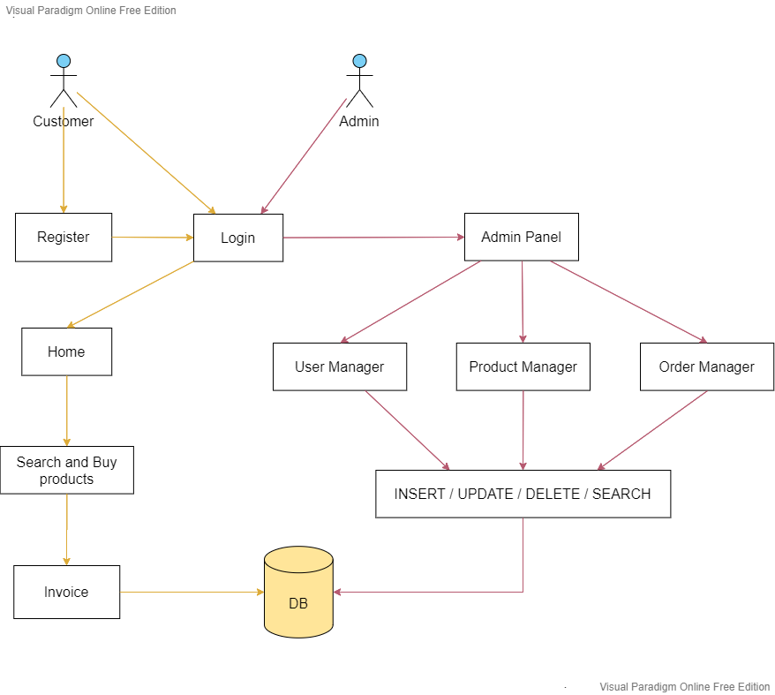

**Product Perspective**

Ultimately, Pharmacy Management System, developed by the project team, will be a new self-contained software solution to overcome the problems resulting from the current manual system. This newly introduced system will simplify the system access process and make it easier for users to interact with the system through user-friendly eye-catching interfaces. With the new system, computing errors in calculations, handling large data sets and other tasks outlined by clients will become easier. By turning this project into a reality, the Hotel will be able to handle almost all its tasks much more efficiently.

**Functional Requirements**

**Registration**

* Through the web application, customers should be able to register their information in the database.
* The database will be updated with information such as the customer's first and last name, age, email address, address, username, date of birth, and password.

**Logging In**

* By identifying whether the username and password that the customer has entered are true or false, this application will check if the details entered are accurate when the user logs in. If true, it will allow the user in.

**Purchasing**

* Through the web application, customers are provided with the ability to search for whatever product they need from the keyword they have searched.
* Using the web application, you can obtain accurate data on the quantities and prices of each product.
* A separate database table is maintained for the purchased details, including the product purchased and the customer who made the purchase

**Accessibility**

* This web application is divided into two main sections according to accessibility, which are the admin section and customer section. The admin section is restricted to all customers. But the customer section does not have any restrictions. The admin section can only be accessed via a specific username and password for managing the database functions in the web application.

**Payment Management System**

* The customers can pay their amount through the PayHere payment gateway and through this they are capable of selecting their required payment method and pay for the order in an effective manner.

**User Interfaces**

**Home page**

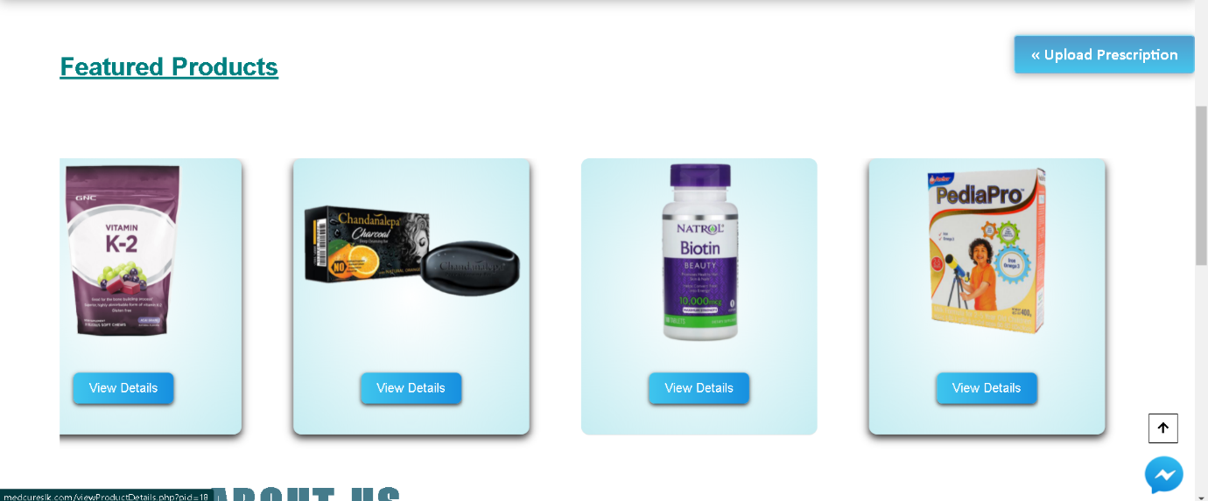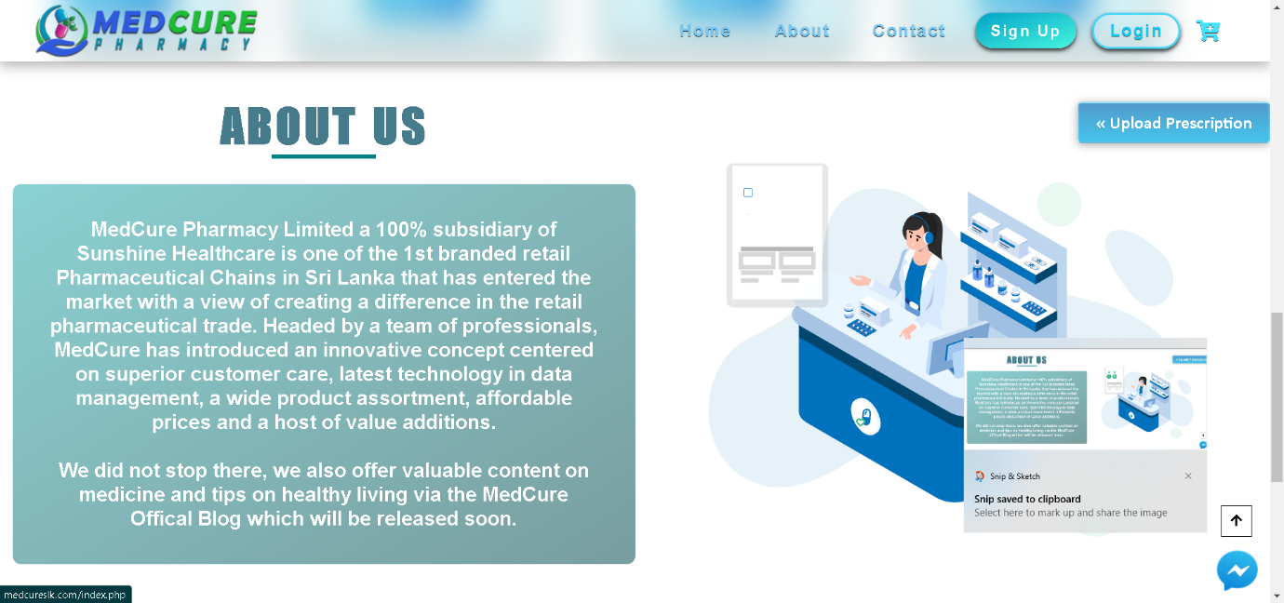

**Header Footer**

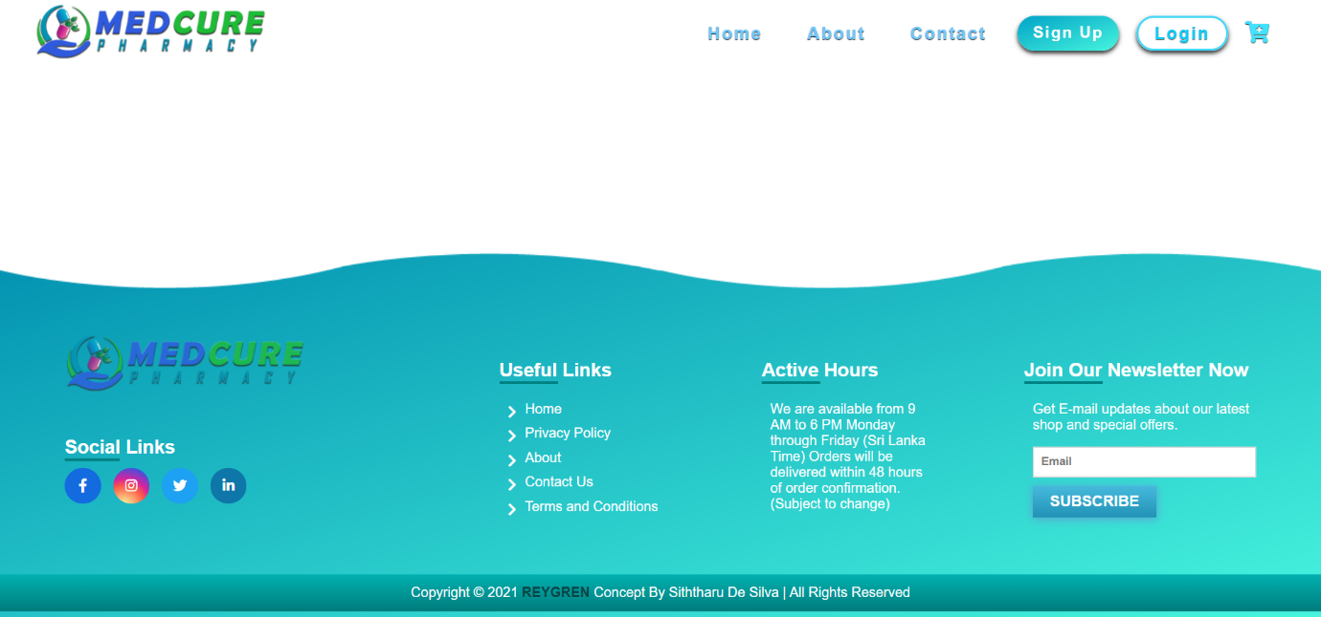

**Login page**

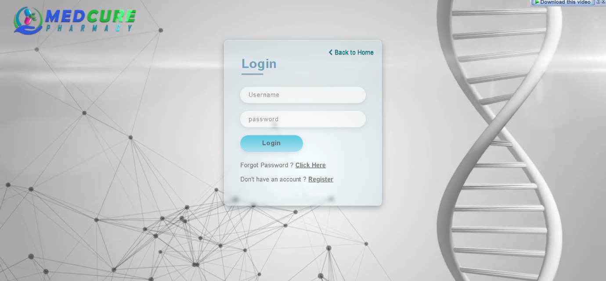

**Sign up page**

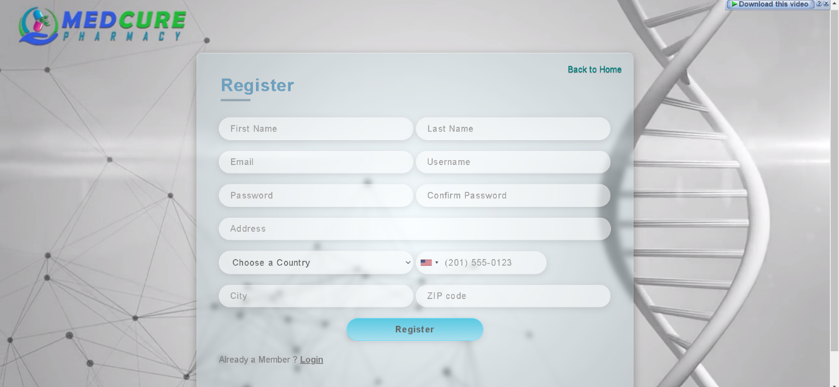

**Products page**

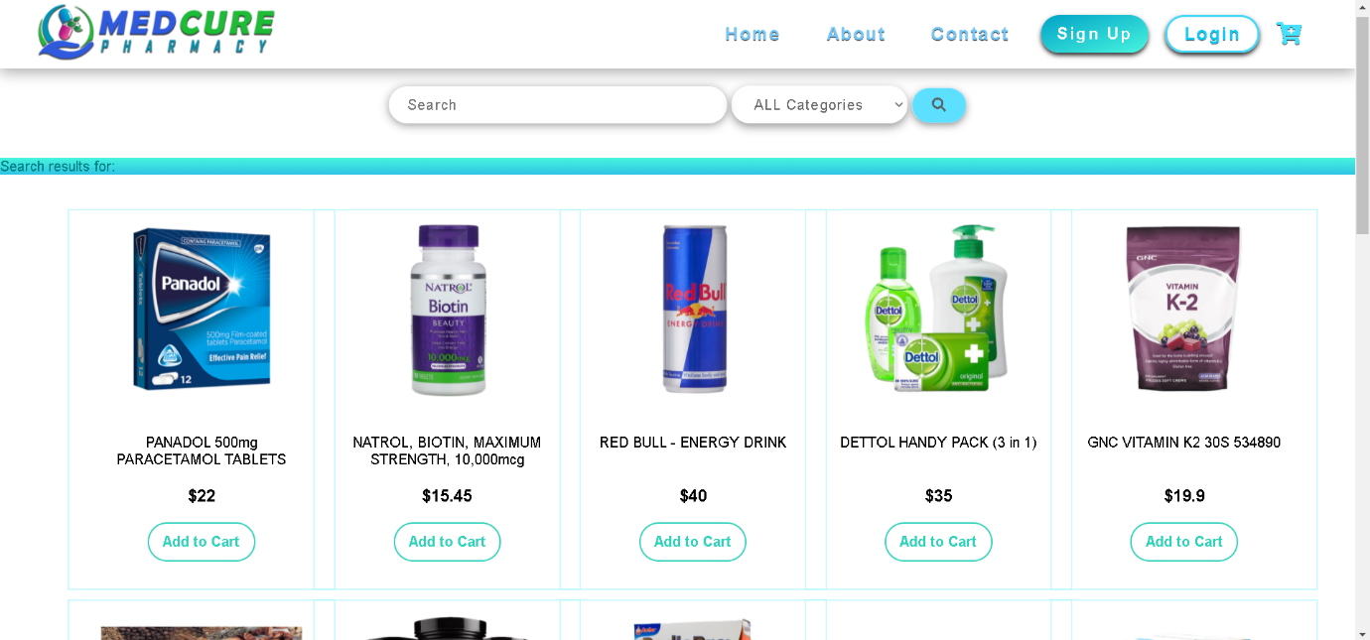

**View products page**



**Prescriptions page**

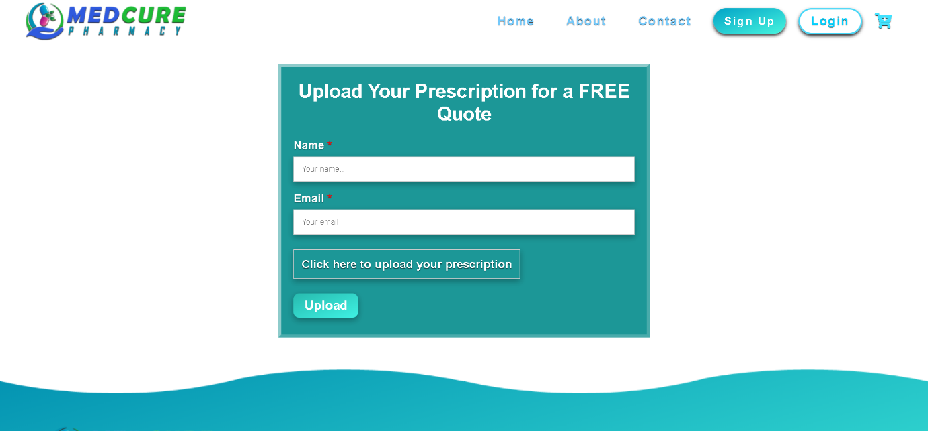

**Contact us page**

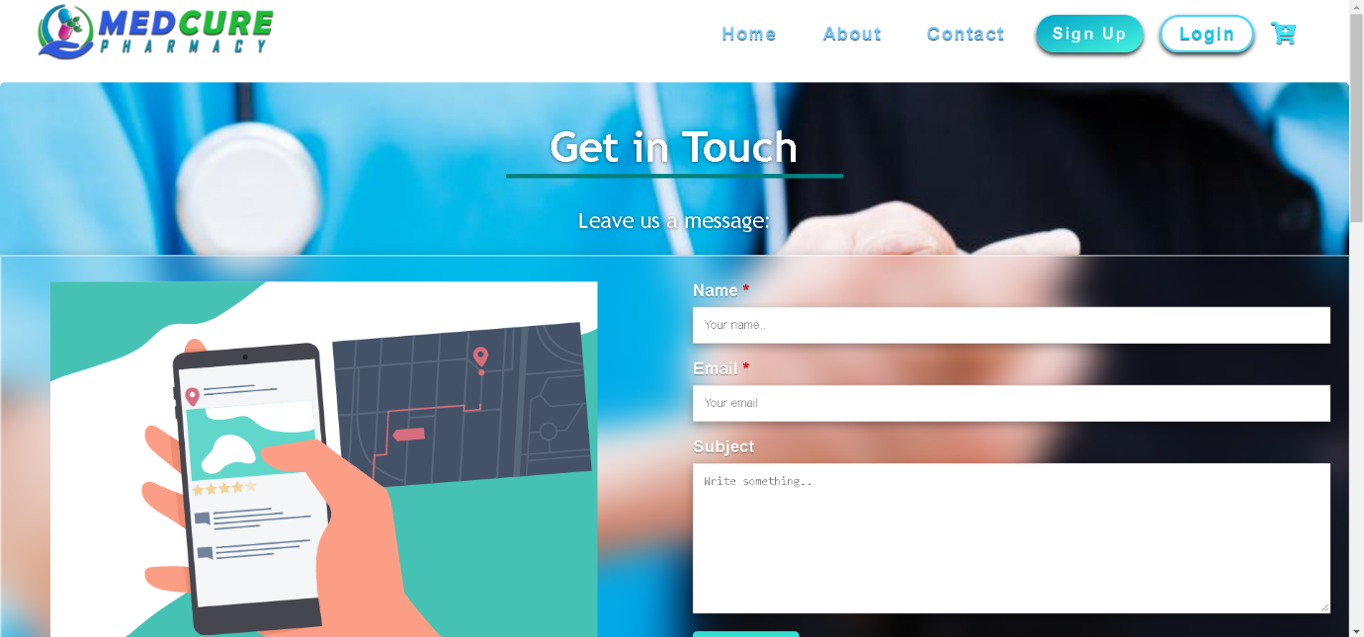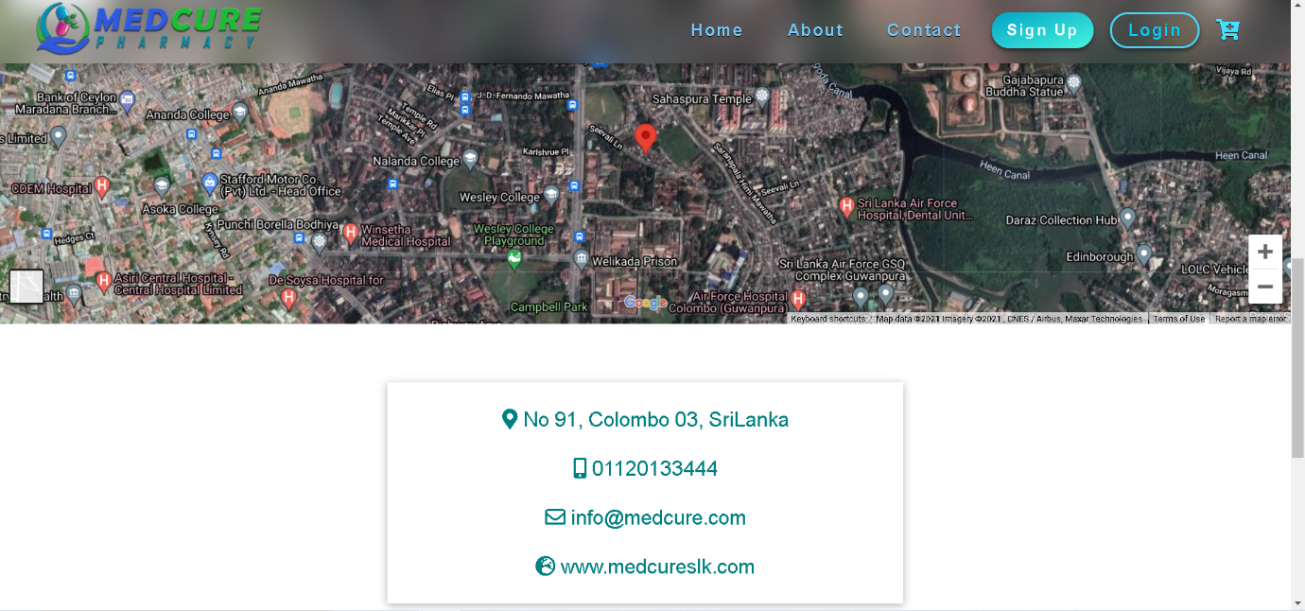

**Admin page**

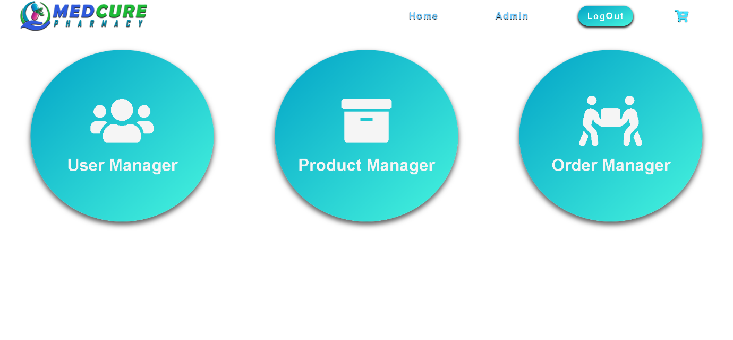

**Cart page**

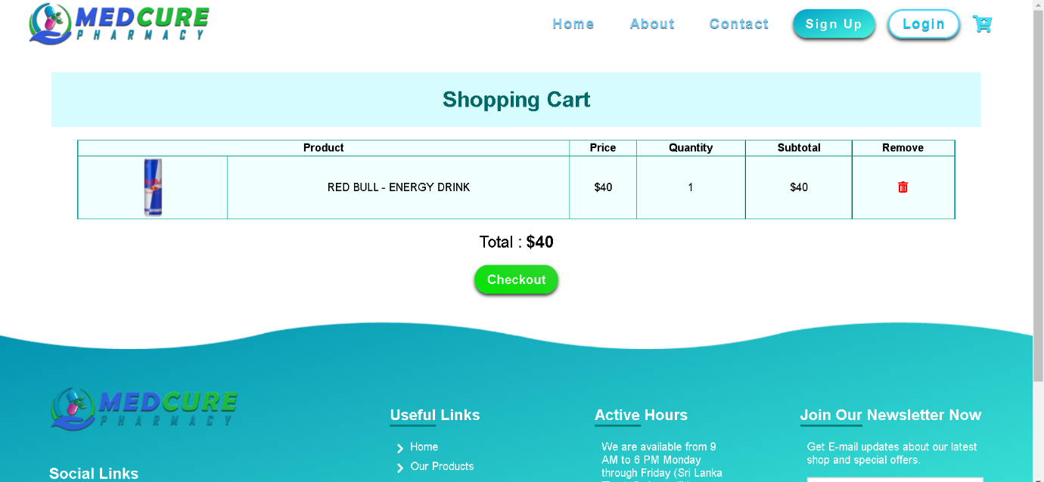

**Checkout Page**

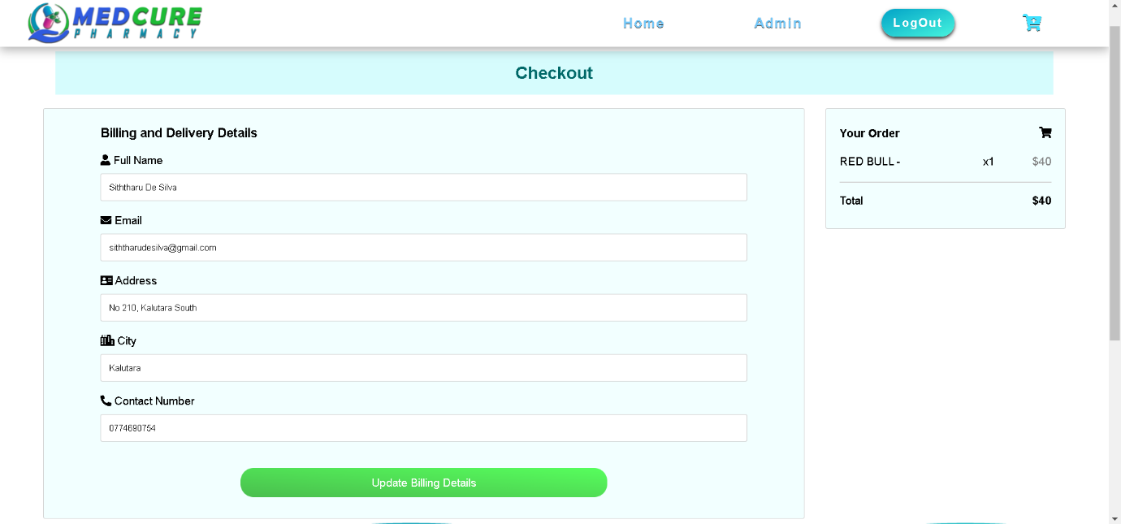

**Conclusion**

So, when I consider all the functions which I had included in this web application, I can conclude that I have created this web application for fulfilling all the essential requirements which a web application for a online pharmacy management system should possess and also by fulfilling the requirements of all the end users who uses this system for their benefits.